Muckraker Summary Chart

Name | Picture | What Industry or Social problem in America did I work to clean up?
Ida Tarbel | 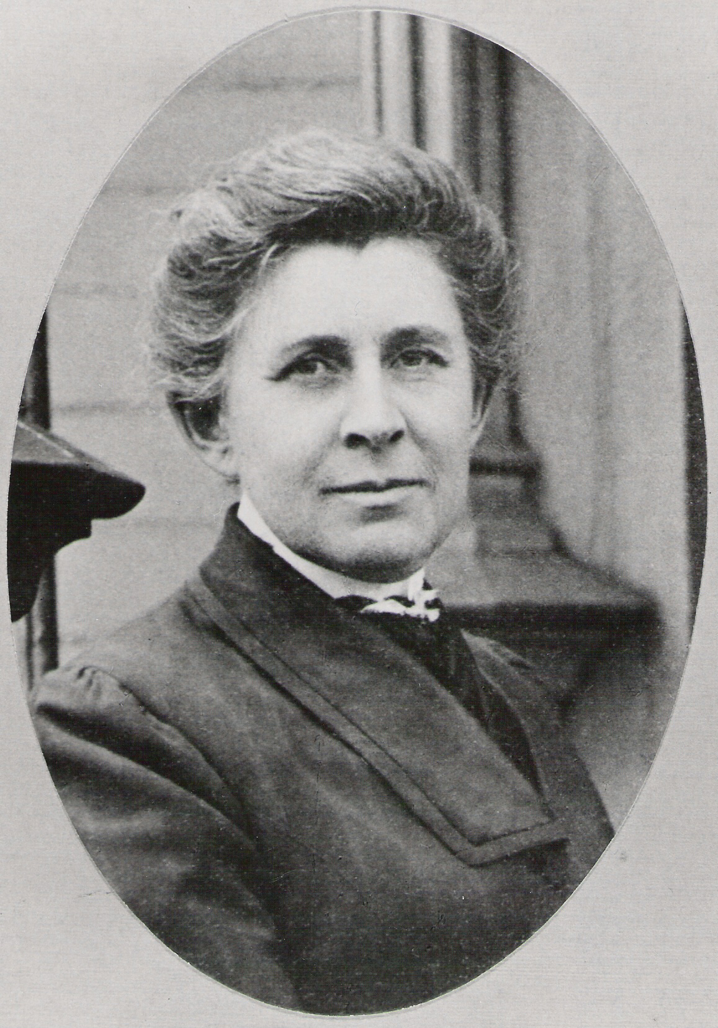
Lincoln Steffens
Jacob Riis
Upton Sinclair
John Spargo
Robert M. LaFollette
W.E.B. DuBois
Jane Adams
Susan B. Anthony

