Create Your Own Country Project

1) What Type of Government Do You Have? (4 points)

_____________________ mixed with ____________________________

2) What type of Economy Do You Have? (4 points)

____________________ mixed with ____________________________

3) What are the values of your country? (4 points)

4) Integrate the Social Contract into the explanation of your country (4 points)

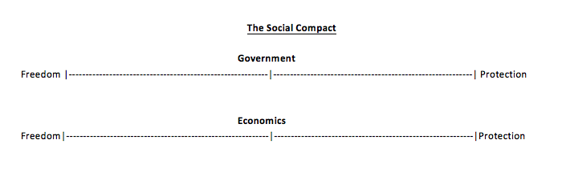

5) How will your government … ? (4 points)
a. Maintain Order
b. Provide Public Service
c. Provide National Security
d. Make Economic Decisions

6) Your Preamble (4 points)

7) Your Articles
} (8 points for both)
8) Your Bill of Rights

9) Flag (8 points)

10) Bonus points for Citizens ______________

TOTAL: _______ / 40 points

